Stox

Trade Smart. Grow Fast

**SmartBridge MERN Stack Project**

*Submitted by*

**Anushka Singh- 22BAI10178**

**Ashish Kumar- 22BCE11353**

**Mandeep Singh Chhabra- 22BAI10425**

Team ID: SWTID1744994612

VIT Bhopal University

Sehore- 466114

Madhya Pradesh

April 2025

1. **Introduction**

## Project Overview

Stox is a comprehensive, full-stack stock trading application developed using the MERN stack—MongoDB, Express.js, React.js, and Node.js. This robust technology stack enables a smooth, responsive, and high-performance experience, making Stox an ideal solution for modern-day investors and traders.

The primary goal of Stox is to simplify the stock trading process and empower users to manage their investments with confidence. Users can buy and sell stocks, monitor real-time market data, track portfolio performance, and gain meaningful insights into their trading patterns—all within a single platform.

Stox offers a clean, intuitive user interface that caters to individuals with varying levels of trading experience. Whether you’re just starting out or a seasoned investor, the platform ensures that you can navigate features with ease. From adding new trades and viewing detailed transaction histories to analyzing trends through dynamic charts and graphs, every feature is designed to enhance decision-making and user convenience.

Security and privacy are at the heart of Stox. The application includes a secure login and user authentication system to protect sensitive information and ensure that all trading data remains private and accessible only to the respective user.

In addition to core trading functionalities, Stox provides insightful reporting tools and real-time visualizations to help users understand their portfolio’s performance and market movements. These features assist users in identifying opportunities, avoiding risks, and making well-informed trading decisions.

Whether you are managing a small personal portfolio or actively trading, Stox gives you the tools, insights, and confidence to take control of your financial future.

## Purpose

Financial challenges are a common concern among individuals, especially in the current economic climate. With the rising cost of energy, food, and everyday essentials, managing finances and seeking opportunities for growth have become more critical than ever. According to a report by the National Union of Students (NUS) in July, one in three students in the UK has less than £50 left each month after covering rent and bills, and a staggering 96% are cutting back on spending to cope with financial pressure (Staton, 2022).

In light of these challenges, many individuals, including students, are exploring investment opportunities to build financial security for the future. However, navigating the world of stocks and investments can be complex without the right tools and guidance. Developing sound investment habits and having access to real-time financial insights are crucial to making informed decisions.

Modern stock management and investment platforms have introduced features that allow users to monitor their portfolios, track stock performance, and access market insights, helping them manage their finances more effectively. Inspired by this concept, this project aims to develop a **user-centric stock management and investment website** using the MERN stack (MongoDB, Express.js, React.js, and Node.js).

The goal is to create a platform that empowers users—especially beginners—to manage their stock portfolios, track investments, and visualize market trends through intuitive dashboards and real-time updates. The clean and accessible interface is designed to cater to users with varying levels of financial and technical expertise.

Beyond basic portfolio tracking, the website will:

• Offer smart investment tips and personalized suggestions based on user preferences and market trends.  
• Enable users to set investment goals and receive alerts or notifications about significant market movements or portfolio changes.  
• Ensure secure data handling and authentication, safeguarding sensitive financial and personal information.  
• Incorporate responsive design for seamless performance across devices, from mobile phones to desktop browsers.

The core research questions driving this project include:

• How can the MERN stack be leveraged to develop an efficient, scalable, and user-friendly stock management and investment platform?  
• In what ways can the website ensure security, data privacy, and integrity while handling sensitive investment data?  
• What specific features and user experience elements are most effective in promoting financial literacy and encouraging smart investment practices among users?

In this report, we will evaluate the design, functionality, usability, scalability, and security of the website. Through real-user feedback and technical analysis, we aim to demonstrate how the platform meets its objectives and addresses the financial challenges faced by today's emerging investors.

# Ideation Phase

## Problem Statement

In today’s fast-paced and digitally-driven world, managing investments effectively has become increasingly challenging for many individuals. With numerous market opportunities, fluctuating stock prices, and the complexity of investment options, it’s easy for portfolio management to become overwhelming. The lack of a centralized, easy-to-use platform for stock management often results in missed opportunities, poorly diversified portfolios, and increased anxiety around financial growth.

This growing concern underscores the need for a smart, user-centric solution that not only simplifies investment tracking but also actively supports better financial decision-making.

The **Stox** platform is designed to meet this need by offering a streamlined, intuitive website where users can effortlessly manage their stock portfolios, monitor market trends, and visualize their investment performance over time. The aim is to make investing simple, insightful, and accessible to everyone—regardless of their experience level with the stock market.

Built with modern web technologies, Stox provides:

• A clean and responsive user interface for easy navigation and quick portfolio updates.  
• Real-time analytics and graphical summaries that highlight investment performance and market trends.  
• Customizable portfolio management tools that allow users to set investment goals, receive alerts about market movements, and track progress toward financial targets.  
• Secure user authentication and encrypted data storage to ensure privacy and build user trust.  
• Multi-device compatibility, allowing users to manage their investments anytime, anywhere.

By delivering a comprehensive set of tools within a single, user-friendly platform, Stox empowers individuals to take charge of their financial future, make informed investment decisions, and work toward achieving long-term financial success.

Through this project, we aim to not only address a practical problem but also encourage greater financial literacy, strategic thinking, and responsible investing in everyday life.

|  |  |  |  |  |  |
| --- | --- | --- | --- | --- | --- |
| **Problem Statement (PS)** | **I am (Customer)** | **I’m trying to** | **But** | **Because** | **Which makes me feel** |
| PS-1 | |  | | --- | |  |  |  | | --- | | A college student new to investing | | Start building a small stock portfolio | I often miss tracking my stock performance | The available tools are too complex and overwhelming for beginners | Frustrated with slow progress and worried about making poor investment choices |
| PS-2 | A young working professional aiming for financial growth | Consistently invest and monitor returns | I don’t have a clear overview of how my portfolio is performing | Investment insights are scattered across multiple platforms and hard to interpret | Anxious about missed opportunities and unsure about next steps in investing |

## Empathy Map

In the **Stox** project, an empathy map serves as a vital tool to deeply understand and visualize the experiences, behaviors, and emotions of users managing their stock investments. By capturing what users say, think, do, and feel, the empathy map guides the design and development process to create a more user-centric investment platform.

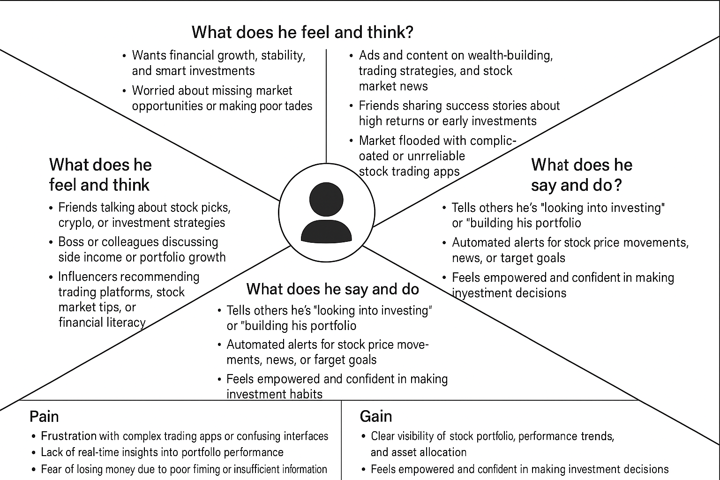

## Brainstorming

The brainstorming phase was essential in laying the groundwork for the **Stock Management and Investment Website**. It included focused discussions, idea generation sessions, and an analysis of user needs, all aimed at identifying key functionalities and crafting a solution that effectively addresses common challenges in managing investments and portfolios.

During this stage, we explored the following critical questions:

• What are the typical challenges people encounter when tracking stocks and investments?  
• What features would make the platform both user-friendly and insightful?  
• How can investment data be presented clearly, accurately, and attractively?  
• Which technologies are best suited for a scalable, modern, and secure investment management system?

From these sessions, the following core features were defined:

• User authentication for secure, personalized portfolio access.  
• Functionality to add, edit, and remove investment assets.  
• Categorization of stocks (e.g., by sector, type, performance).  
• A dashboard to visually summarize portfolio value, gains/losses, and market trends.  
• Real-time data updates without the need for page reloads.  
• A clean and intuitive interface for smooth navigation and easy portfolio management.

The team also finalized the **MERN stack** (MongoDB, Express.js, React.js, Node.js) as the ideal technology choice, offering flexibility, scalability, and strong performance for this full-stack platform.

In conclusion, the brainstorming phase helped solidify the project’s direction and define a clear path toward development.

# Requirement Analysis

## Customer Journey Mapping

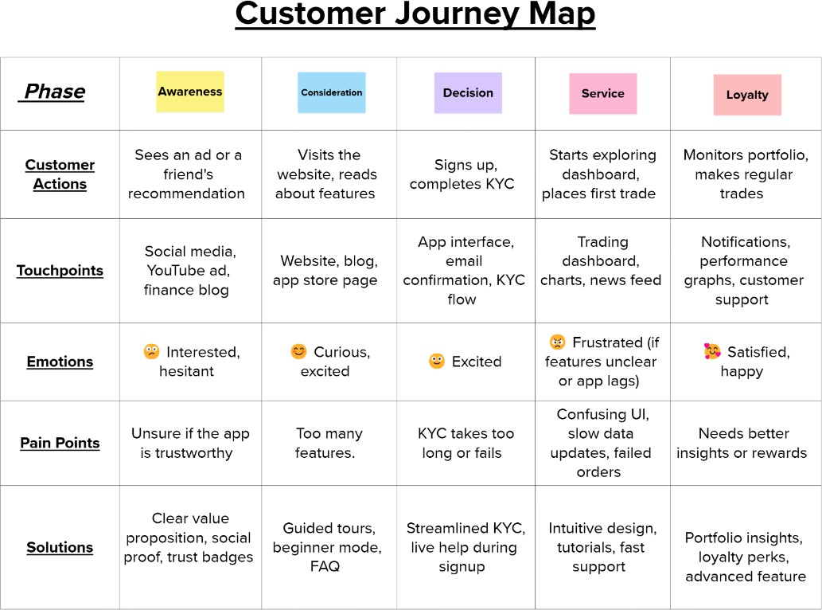

* 1. **Data Flow and User Stories**

Project Design Phase-II

Data Flow Diagram & User Stories

|  |  |
| --- | --- |
| **Date** | 31 January 2025 |
| **Team ID** | SWTID1744994612 |
| **Project Name** | Stox - Trade Smart. Grow Fast |
| **Maximum Marks** | 4 Marks |

## Data Flow Diagrams

A Data Flow Diagram (DFD) is a classic method of visually illustrating the flow of information within a system. A well-organized and precise DFD graphically represents the essential system requirements. It outlines how data is input and output, how it is processed, and where it is stored within the system.

***LEVEL 0 DFD***

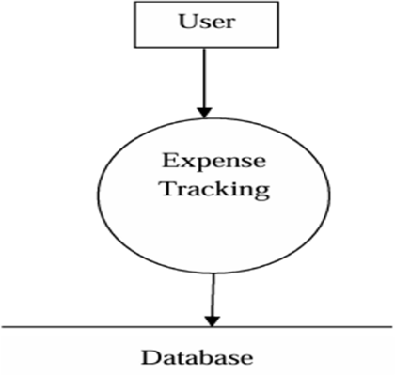

***LEVEL 1 DFD***

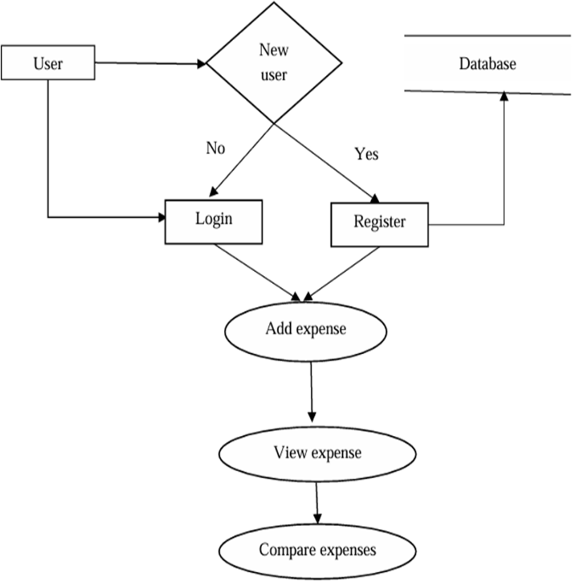

Example:

|  |  |  |  |  |  |  |  |  |
| --- | --- | --- | --- | --- | --- | --- | --- | --- |
| **User Type** | **Functional Requirement (Epic)** | **User Story**  **Number** | **User Story / Task** | | **Acceptance Criteria** | | **Priority** | **Release** |
| Custom er (Mobil e user) | Registration | USN-1 | As a user, I can register for Stox by entering email, password, and confirming it | | I can access my Stox account / dashboard | | High | Sprint-1 |
|  | Registration | USN-2 | As a user, I will receive a confirmation email after registering | | I receive a confirmation email & can click confirm | | High | Sprint-1 |
|  | Registration (Social Login) | USN-3 | As a user, I can register using Facebook | | I can log in & access dashboard via Facebook | | Low | Sprint-2 |
|  | Registration (Social Login) | USN-4 | As a user, I can register using Gmail | | I can log in & access  dashboard via Gmail | | Medium | Sprint-1 |
|  | Login | USN-5 | As a user, I can log into Stox using email and password | | Login is successful & I can view home screen | | High | Sprint-1 |
|  | Dashboard | USN-6 | As a user, I can view my monthly portfolio performance summary on the dashboard. | | Dashboard shows categorized stock holdings, gains/losses, and total portfolio value. | | High | Sprint-2 |
| Custom er (Web user) | |  | | --- | | Stock Entry & Categorization |  |  | | --- | |  | | USN-7 | As a user, I can add and categorize stocks by type (e.g., Technology, Healthcare) | | Stock appears in the correct category | | High | Sprint-2 |
|  | Investment Goal Setting | USN-8 |  | As a user, I can set investment goals (e.g., savings target, portfolio growth) | Goals are saved and shown in analytics |  | Medium | Sprint-3 |
|  |  | |

|  |  |  |  |  |  |  |  |
| --- | --- | --- | --- | --- | --- | --- | --- |
|  |  | |  |  |  |  |  |
| Custom er Care Executi ve | Support Ticket System | | USN-9 | As an executive, I can view and manage user queries about investments | Queries are shown in a dashboard with filters & status updates | High | Sprint-3 |
|  |  |  | USN-10 | As an admin, I can view stats like active users, top-performing stocks, investment trends, etc. | Dashboard loads reports correctly based on date range | High | Sprint-2 |
| User Analytic  s | Portfolio Management System | |
|  |  |  |
|  | User Analytics | | USN-11 | As an admin, I can view usage stats like most-watched stocks, portfolio activities | Dashboard loads reports correctly based on date range | Medium | Sprint-4 |

## Solution Requirements (Functional & Non-functional)

### Functional Requirements:

Following are the functional requirements of the proposed solution.

|  |  |  |
| --- | --- | --- |
| **FR No.** | **Functional Requirement (Epic)** | **Sub Requirement (Story / Sub-Task)** |
| FR-1 | User Onboarding | Registration through Form |
| Sign up with Gmail |
| Sign up with LinkedIn |
| FR-2 | Account Confirmation | Confirmation via Email |
| Confirmation via OTP |
| FR-3 | User Login | Login via Email |
| OAuth 2.0 Token-Based Session Management |
| Logout Functionality |
| FR-4 | Content Browsing | Fetch portfolio data via Brokerage APIs |
| Search Functionality for stocks/assets |
| Filter by Asset Type, Date, Value |

|  |  |  |
| --- | --- | --- |
| FR-5 | Finance Profile Management | View Financial Dashboard |
| Edit Financial Goals |
| FR-6 | Budget Goals | Add to Budget Goals |
| Remove from Budget Goals |
| View Budget Goals |
| FR-7 | |  | | --- | | Trade Tracker Integration |  |  | | --- | |  | | Track Trades (Buy/Sell activities) |
| Edit/Delete Trade Entry |
| Continue Tracking from Last Trade |

### Non-functional Requirements:

Following are the non-functional requirements of the proposed solution.

|  |  |  |
| --- | --- | --- |
| **NFR No.** | **Non-Functional Requirement** | **Description** |
| NFR-1 | Usability | **Stox** offers a intuitive and clean UI designed for ease of navigation across devices. |
| NFR-2 | Security | User data is protected with encryption and OAuth 2.0-based authentication. |
| NFR-3 | Reliability | System will be tested for fault-tolerance and uptime with robust error handling. |
| NFR-4 | Performance | Optimized API calls, lazy loading, and caching for smooth experience. |
| NFR-5 | Availability | 99.5% uptime aimed through cloud deployment and load-balanced architecture. |
| NFR-6 | Scalability | Built using scalable technologies (Firebase Realtime DB, Python Flask, Flutter) with future microservices support. |

## Technology Stack

### Technical Architecture:

* Frontend
  + React.js: A JavaScript library used to develop interactive and responsive user interfaces.
  + Tailwind CSS: A utility-first CSS framework for creating consistent and adaptive designs.
* Backend
  + Node.js: A JavaScript runtime that enables server-side code execution.
  + Express.js: A lightweight and flexible framework for building APIs in Node.js.
* Database
  + MongoDB: A NoSQL database offering scalable and flexible data management.
* Authentication
  + JSON Web Tokens (JWT): Used to implement secure, stateless authentication and authorization.

Table 1: Tech Stack

|  |  |  |
| --- | --- | --- |
| **Component** | **Technologies** | **Purpose** |
| Frontend | React.js | Dynamic UI development |
| Material-UI | Pre-styled components |
| Redux Toolkit | State management |
| Backend | Node.js + Express.js | REST API server logic |
| MongoDB | NoSQL database for portfolios/users |
| Mongoose | Database schema modeling |
| Authentication | JWT | Token-based user security |
| Deployment | Vercel | Frontend hosting |
| Render | Backend server deployment |
| Testing | Jest + React Testing Library | Unit/component testing |

Table 2: Features

|  |  |
| --- | --- |
| **Category** | **Details** |
| Functional | Add/delete stock entries with categories (e.g., sector, asset type) |
| Visualize portfolio trends via charts |
| Set investment targets and receive alerts |
| Non-Functional | Responsive design (mobile/desktop) |
| Secure API endpoints (JWT authentication) |
| - Optimized performance with lazy loading |

# Project Design

## Problem Solution Fit

Many individuals face difficulties in managing their investments due to the lack of easy-to-use and accessible platforms. This often results in challenges with tracking stock performance, understanding portfolio behavior, and making well-informed investment decisions.

**Proposed Solution:**

Stox provides a web-based platform that enables users to:

• Add and categorize their stock investments.  
• Visualize portfolio trends and market movements through clear and intuitive dashboards.  
• Set and track investment goals to monitor progress and growth.

By offering these features, Stox aims to help users take control of their investments, fostering smarter decision-making and long-term financial growth.

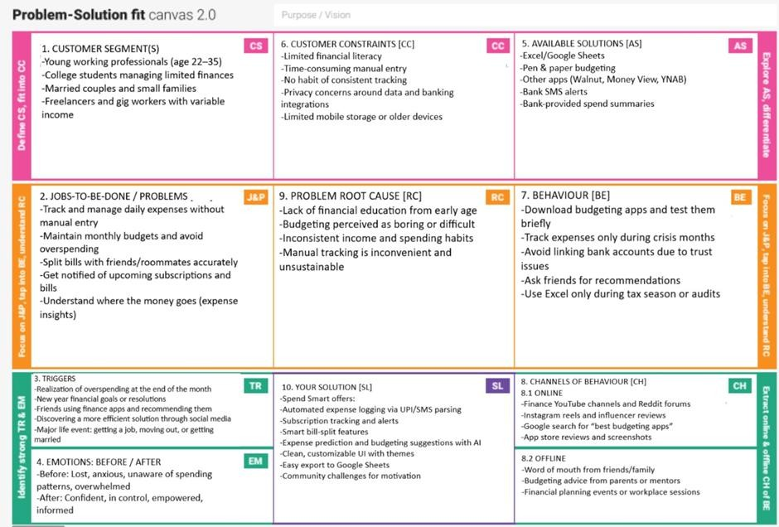

## Proposed Solution

|  |  |  |
| --- | --- | --- |
| **Sl. No.** | **Parameter** | **Description** |
| 1 | Problem Statement (Problem to be solved) | Many individuals face challenges managing their investments due to inconsistent tracking, limited portfolio insights, and a lack of easy-to-use platforms. Manual tracking is tedious, while existing tools are often either overly complicated or lack real-time data integration. |
| 2 | Idea / Solution description | Stox is an intelligent stock management and investment tracking platform that automates portfolio updates, fetches real-time stock prices, and provides AI-driven investment insights. It features goal setting, market alerts, and easy visualization tools to help users stay informed and confident. |
| 3 | Novelty / Uniqueness | |  | | --- | | Unlike traditional stock tracking apps, Stox emphasizes real-time automation, personalized investment advice, and a gamified user experience. It blends investment education, portfolio analytics, and actionable insights into a simple, engaging, and beginner-friendly platform. |  |  | | --- | |  | |
| 4 | Social Impact / Customer Satisfaction | |  | | --- | | Stox promotes financial literacy and smarter investing, especially among young investors and first-time stock market participants. By demystifying investments and reducing decision-making stress, it enhances financial empowerment and satisfaction. |  |  | | --- | |  | |
| 5 | Business Model (Revenue Model) | Stox adopts a freemium model: core tracking features are free. Premium plans offer advanced insights, customized investment recommendations, portfolio analysis reports, and ad-free usage. Additional revenue streams include affiliate partnerships with financial institutions (e.g., brokerage services, mutual funds). |
| 6 | Scalability of the Solution | Stox is designed for high scalability — it can be expanded to multiple regions with language and currency localization. Future enhancements may include partnerships with financial institutions, support for shared budgeting among families or groups, and integration with corporate financial wellness programs. |

* 1. **Solution Architecture**

The Stox application is built using the MERN stack, which consists of:

* MongoDB: A NoSQL database that provides flexible data storage.
* Express.js: A web application framework for building efficient APIs with Node.js.
* React.js: A JavaScript library for creating dynamic and responsive user interfaces.
* Node.js: A JavaScript runtime environment for executing server-side code.

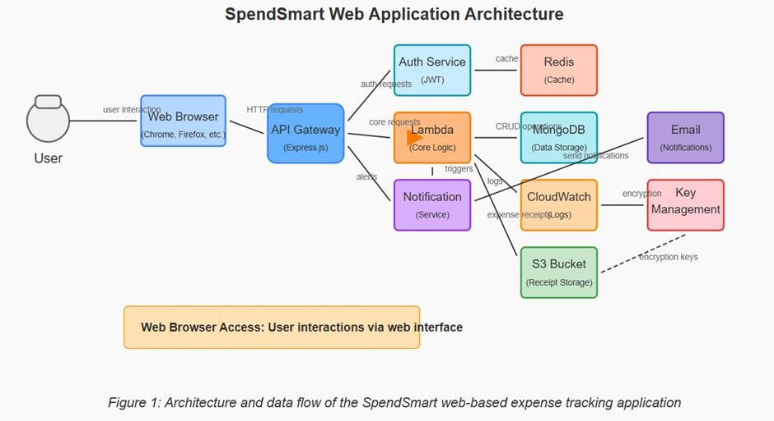

# Project Planning & Scheduling

**Definitions:**

* **Sprint**: A fixed time period (usually 5–10 days) during which a team completes a set of tasks.
* **Epic**: A large feature or functionality in **Stox** that cannot be completed in a single sprint and is broken into smaller Stories.
* **Story**: A manageable unit of financial tracking or planning work within an Epic.
* **Story Point**: A numeric value indicating the effort or complexity involved, often based on the Fibonacci sequence (1, 2, 3, 5, 8...).

### Sprint 1 (Duration: 5 Days)

Epic: Investment Data Preparation

|  |  |  |
| --- | --- | --- |
| **Task** | **Story Points** | **Complexity** |
| Collection of Stock Market Data | 2 | Easy |
| |  | | --- | | Loading Historical Price Data |  |  | | --- | |  | | 1 | Very Easy |
| |  | | --- | | Filling Missing Stock Entries |  |  | | --- | |  | | 3 | Moderate |
| |  | | --- | | Categorizing Stocks by Sector |  |  | | --- | |  | | 2 | Easy |

Total Story Points (Sprint 1): 8

### Sprint 2 (Duration: 5 Days)

Epic: Categorization Logic & Deployment

|  |  |  |
| --- | --- | --- |
| **Task** | **Story Points** | **Complexity** |
| Sector Categorization Algorithm | 5 | Difficult |
| Validation of Stock Categories | 3 | Moderate |
| UI Screens with Flutter (e.g., Portfolio Overview) | 3 | Moderate |
| Firebase Deployment for Portfolio Data Sync | 5 | Difficult |

Total Story Points (Sprint 2): 16

Velocity Calculation

|  |  |
| --- | --- |
| **Metric** | **Value** |
| Total Story Points | 8 (Sprint 1) + 16 (Sprint 2) = 24 |
| Number of Sprints | 2 |
| Velocity | 24 ÷ 2 = 12 Story Points/Sprint• Team’s Velocity: 12 Story Points per Sprint |

Product Backlog, Sprint Schedule, and Estimation (4 Marks)

|  |  |  |  |  |  |  |
| --- | --- | --- | --- | --- | --- | --- |
| **Sprint** | **Functional Requirement (Epic)** | **User Story Numbe r** | **User Story / Task** | **Story Points** | **Priority** | **Team Members** |
| Sprint-1 | Registration | USN-1 | As an investor, I can create an account with email and password to access the stock investment platform. | 2 | High | Mandeep Singh Chhabra |
| Sprint-1 | Registration | USN-2 | As an investor, I receive a confirmation email after successful account registration. | 1 | High | Mandeep Singh Chhabra |
| Sprint-2 | Login | USN-3 | As an investor, I can log in using my credentials to manage my investments. | 1 | High | Ashish Kumar |
| Sprint-2 | Login | USN-4 | As an investor, I get an error message if I enter incorrect credentials during login. | 2 | Medium | Mandeep Singh Chhabra |
| Sprint-2 | Dashboard | USN-5 | As an investor, I can view a dashboard summarizing my portfolio performance, holdings, and stock value changes. | 3 | High | Mandeep Singh Chhabra |
| Sprint-3 | |  | | --- | | Investment Tracking |  |  | | --- | |  | | USN-6 | As an investor, I can add and track my stock purchases and sales with details like quantity, price, and sector category. | 3 | High | Anushka Singh |
| Sprint-3 | |  | | --- | | Investment Tracking |  |  | | --- | |  | | USN-7 | As an investor, I can edit or delete my past stock transactions. | 2 | Medium | Ashish Kumar |
| Sprint-3 | Budgeting | USN-8 | As an investor, I can set investment budgets per sector or stock category (e.g., Tech, Healthcare). | 3 | Medium | Anushka Singh |
| Sprint-4 | Reports | USN-9 | As an investor, I can generate graphical reports of my portfolio performance and investment trends. | 3 | High | Mandeep Singh Chhabra |

|  |  |  |  |  |  |  |
| --- | --- | --- | --- | --- | --- | --- |
|  |  |  |  |  |  |  |
| Sprint-4 | Notifications | USN- 10 | As an investor, I receive alerts if my investment budget limits are exceeded or significant stock price movements occur. | 2 | Medium | Anushka Singh |

# Functional And Performance Testing

**Testing Scope:**

Features and Functionalities to be Tested:

* User Registration and Authentication
* Stock Purchase and Sale Entry Management
* Portfolio (Investment) Tracking
* Dashboard Visualization and Reporting

**User Stories or Requirements to be Tested:**

* As an investor, I want to register and log in securely.
* As an investor, I want to add, edit, and delete stock transactions.
* As an investor, I want to view my portfolio and investment performance on a dashboard.
* As an investor, I want to generate detailed reports of my investment activities.

|  |  |  |  |  |  |
| --- | --- | --- | --- | --- | --- |
| **Test Case ID** | **Test Scenario** | **Test Steps** | **Expected Result** | **Actual Result** | **Pass/Fail** |
| TC-001 | User Registration | 1. Navigate to the registration page. 2. Enter valid user details. 3. Submit the form. | Investor account is created, and a confirmation message is displayed | As Expected | Pass |
| TC-002 | User Login | Navigate to the login page.   1. Enter valid credentials. 2. Click on the login button | Investor is logged in and redirected to the investment dashboard. | As Expected | Pass |
| TC-003 | Add Stock Transaction | 1. Navigate to the stock transaction page. 2. Click on ‘Add Transaction’ 3. Enter stock purchase/sale details. 4. Save the transaction. | Transaction is added and displayed in the portfolio list. | As Expected | Pass |
| TC-004 | |  | | --- | | Delete Stock Transaction |  |  | | --- | |  | | 1. Navigate to the portfolio list. 2. Select a transaction to delete. 3. Confirm deletion. | Transaction is removed from the portfolio list. | As Expected | Pass |
| TC-005 | View Dashboard | 1. Log in to the application.  2. Navigate to the dashboard. | Dashboard displays a summary of stocks owned, profit/loss, and visual graphs. | As Expected | Pass |

|  |  |  |  |  |  |
| --- | --- | --- | --- | --- | --- |
|  |  |  |  |  |  |

Bug Tracking:

|  |  |  |  |  |  |
| --- | --- | --- | --- | --- | --- |
| **Bug ID** | **Bug Description** | **Steps to reproduce** | **Severity** | **Status** | **Additional feedback** |
| BG-001 | Stock Transaction not saving correctly | 1. Navigate to 'Add Transaction'. 2. Enter details. 3. Click 'Save'. | High | Resolved | Issue was due to missing field validation. |
| BG-002 | |  | | --- | | Portfolio dashboard not loading |  |  | | --- | |  | | Log in to the application.   1. Navigate to the dashboard. 2. Observe that the dashboard does not   load. | Medium | In Progress | Investigating potential API issues. |

# Results

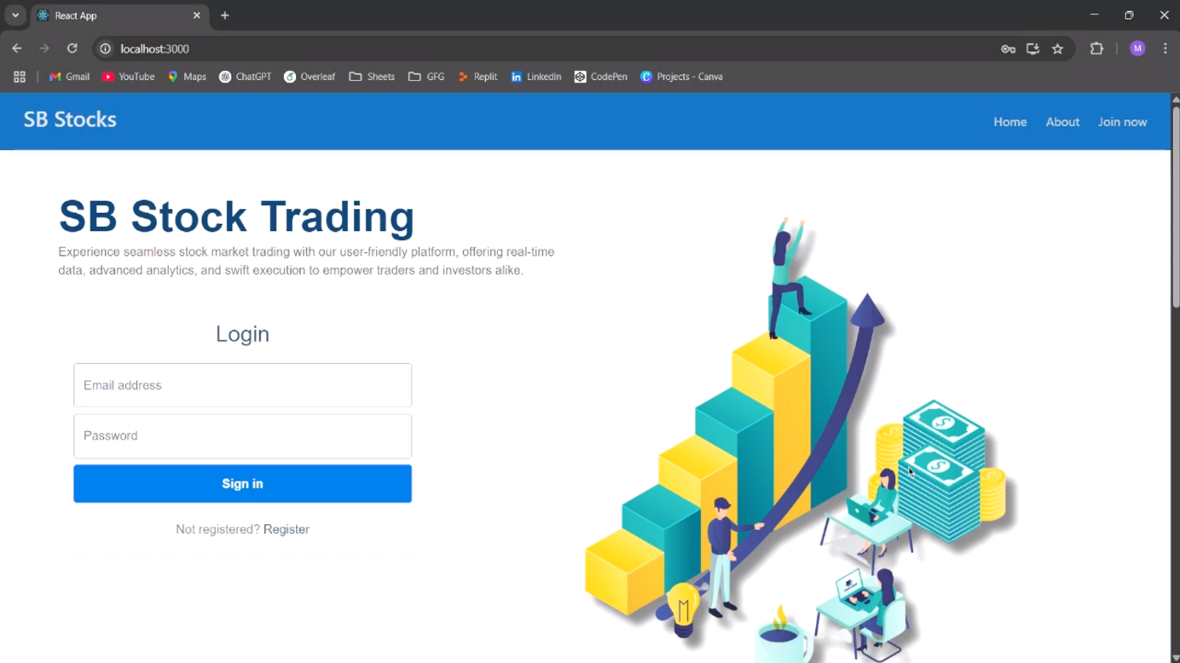

**Login Page**

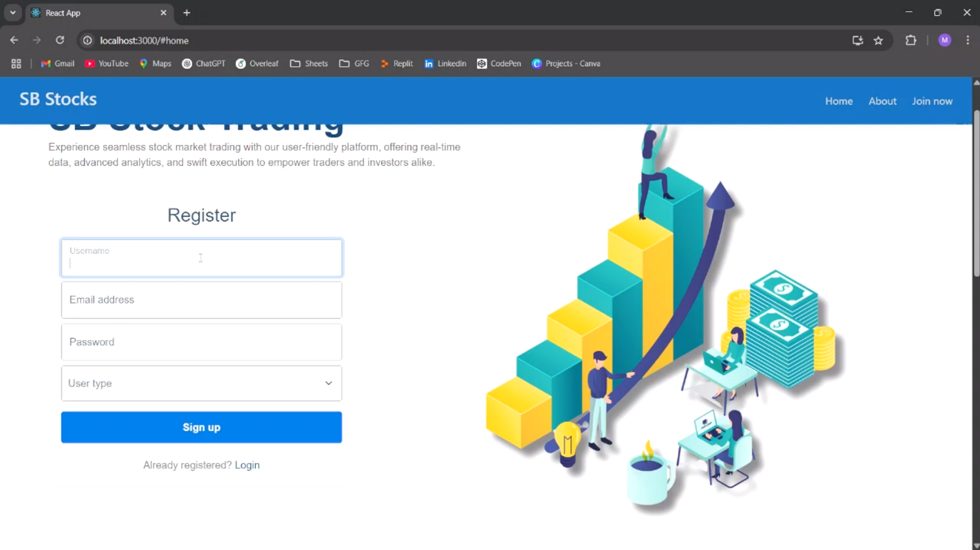

**Registration Page**

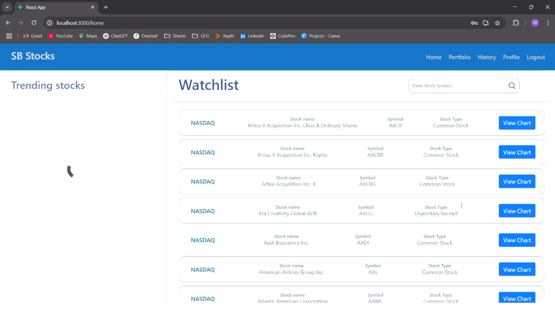

**Watchlist Page**

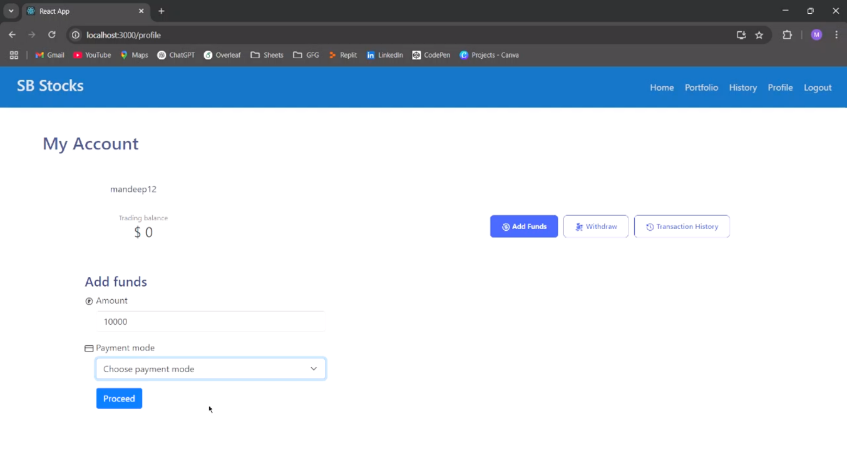

**My Account Page**

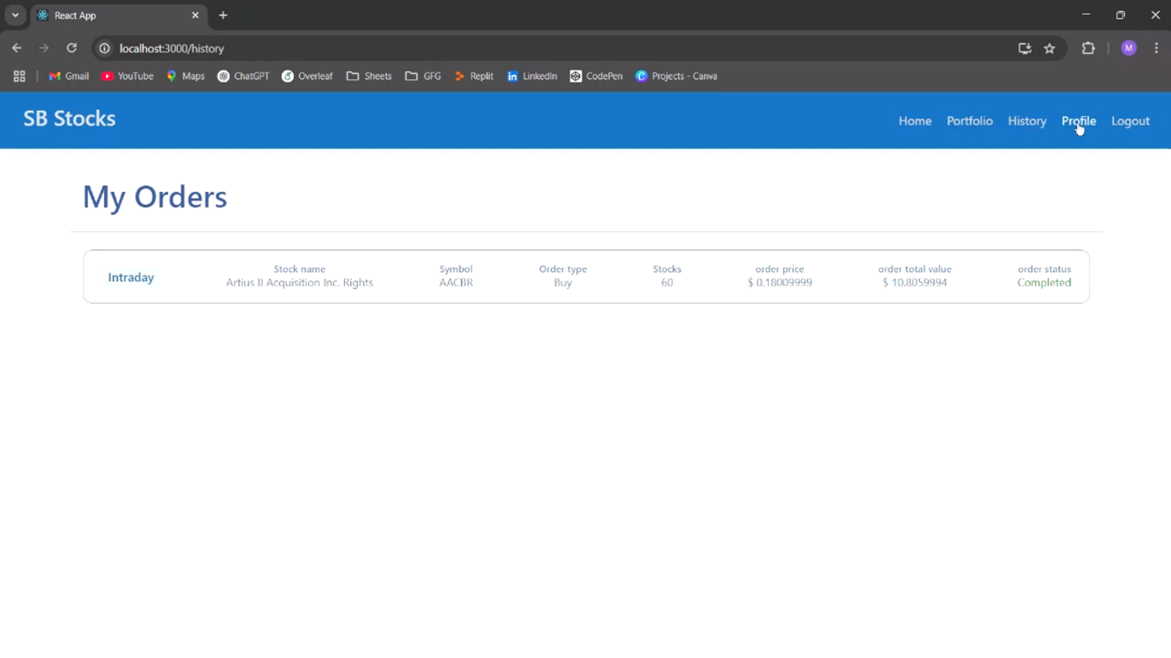

**My Orders Page Page**

# Advantages & Disadvantages

**Advantages**

List the benefits and strengths of the application, especially from the user and technical perspective.

1. **User-Friendly Interface: The app is designed to be intuitive and easy to navigate, even for those new to stock market investing, with a clean and straightforward user interface.**
2. **Real-Time Market Updates: Users can instantly view their portfolio performance and track stock price changes in real-time without needing to refresh the page.**
3. **Secure Authentication:** The login and registration system ensures that user data, including sensitive investment information, remains secure and protected.
4. **Portfolio Categorization:** The app allows users to categorize their investments by industry, asset type, or risk level, making it easier to understand portfolio diversification and performance.

**Cross-Device Accessibility:** As a web app, it can be accessed from any device with a browser and internet connection, enabling users to monitor their investments on the go.

**Disadvantages**

Point out any current limitations, potential user complaints, or features that could be improved.

1. **No Offline Access:** Users cannot access or manage their stock portfolio without an internet connection, limiting usability in areas with unreliable connectivity.
2. **Limited Data Visualization:** While basic charts are available, the app currently lacks advanced analytics, such as predictive analytics or portfolio optimization tools, and does not support data export for offline analysis.
3. **No Mobile App:** Although the web app is mobile-responsive, a dedicated native mobile app would provide a more seamless and optimized experience for users on smartphones and tablets.
4. **Manual Portfolio Updates:** Users must manually update their stock portfolio by entering transactions or changes in holdings. Automated synchronization with brokerage accounts is not yet available.
5. **No Notification or Alert System:** The app does not offer real-time alerts for stock price movements, portfolio performance changes, or important market events, limiting proactive decision-making.

Most of these disadvantages point to potential improvements or future enhancements that could better serve users' evolving needs. Despite these limitations, Stox offers a reliable and user-friendly platform for managing stock investments, meeting the core needs of individual investors.

# Conclusion

The Stox project demonstrates the power of modern web technologies in addressing the needs of stock market investors through a user-centered approach. Built on the MERN stack (MongoDB, Express.js, React, and Node.js), the application offers a seamless, responsive, and efficient platform for users looking to manage their stock investments more effectively. React drives a dynamic and intuitive frontend interface, while Node.js and Express.js provide a robust backend capable of handling numerous user requests with ease. MongoDB, a flexible NoSQL database, ensures secure storage and retrieval of user investment data, supporting smooth and scalable operations.

Key features of Stox include secure user authentication, real-time stock tracking, intuitive categorization of investment portfolios, and insightful data visualizations. These features allow users to track their stock performance in real-time, view historical trends, and make informed decisions. The categorization system helps users group their investments by industry, risk level, or asset class, providing transparency into their portfolio’s structure. Data visualization tools such as line charts, bar graphs, and candlestick charts transform complex financial data into easy-to-understand insights, enhancing user engagement and enabling clearer decision-making.

A strong focus was placed on creating a scalable and maintainable architecture throughout development. The modular codebase and RESTful API design ensure the platform remains easy to maintain while enabling the integration of future features. Performance optimization strategies, including efficient state management and database indexing, ensure the application remains responsive and stable, even with fluctuating market data.

Looking to the future, several exciting enhancements could elevate the platform. These include integration with external financial data sources and stock trading APIs to provide real-time market data and facilitate seamless trading experiences. AI-driven portfolio recommendations and market trend analysis could also be introduced, providing users with personalized investment insights. Additionally, supporting multi-currency transactions and international stock exchanges would broaden the application’s appeal to a global audience.

In conclusion, Stox successfully fulfills its goal of providing a reliable, user-friendly platform for stock investment management. With its current features and well-thought-out architectural design, the application offers significant value to users while remaining flexible and future-ready, positioning itself as a strong foundation for ongoing innovation and expansion.

# Future Scope

The Stox project has built a strong foundation for managing stock investments. To further enhance its capabilities and improve the user experience, the following future developments are proposed:

**Integration with Financial Institutions:**

* **Automated Data Synchronization**: Establish secure connections with stock brokerage accounts and financial institutions to automatically import and update investment data, reducing manual entry and improving data accuracy.

**Artificial Intelligence (AI) and Machine Learning (ML) Enhancements:**

* **Predictive Market Analytics**: Implement AI algorithms to analyze market trends, historical performance, and stock behavior to predict future market movements, helping users make informed investment decisions
* **Smart Stock Recommendations**: Utilize ML models to provide personalized stock recommendations based on user preferences, risk tolerance, and market trends, enhancing investment strategies.

**Mobile Application Development:**

* **Cross-Platform Support**: Develop native mobile applications for iOS and Android, enabling users to easily access and manage their stock portfolios on the go.
* **Offline Functionality**: Allow users to track their investments and receive updates without an internet connection, with automatic synchronization when connectivity is restored.

**Multi-Currency and Global Market Support:**

* **Currency Conversion**: Allow users to manage investments in multiple currencies with real-time exchange rate updates, enabling international investors to track and manage portfolios with ease.
* **Global Stock Market Integration:** Support investments across different stock exchanges worldwide, allowing users to diversify portfolios globally.

**Enhanced Data Visualization and Reporting:**

* **Customizable Dashboards**: Give users the ability to personalize their dashboards to highlight key metrics, such as stock performance, portfolio value, and risk exposure.
* **Advanced Reporting Tools**: Introduce comprehensive reports and insights into portfolio performance, asset allocation, dividend earnings, and risk management to help users optimize their investments.

**Integration with Emerging Financial Technologies:**

* **Cryptocurrency Portfolio Management**: Integrate features to track and manage cryptocurrency investments alongside traditional stocks, providing users with a comprehensive investment overview.
* **Open Financial APIs**: Leverage open banking and financial APIs to facilitate seamless data sharing and enhance investment decision-making with additional financial insights.

**Gamification Elements:**

* **Financial Goals and Rewards**: Introduce goal-setting features with rewards for achieving investment milestones, such as portfolio growth or dividend collection, to motivate users to stay engaged and disciplined in their investment strategies.
* **Stock Trading Challenges:** Create challenges that encourage users to make smart investment decisions, such as achieving specific returns or diversifying portfolios, promoting healthy financial habits and engagement**.**

Implementing these advancements will position Stox at the forefront of investment management, offering users a comprehensive, intelligent, and user-centric platform for optimizing their financial futures.

# Appendix

**Source Code Repository:**

**Project Demo Link:**